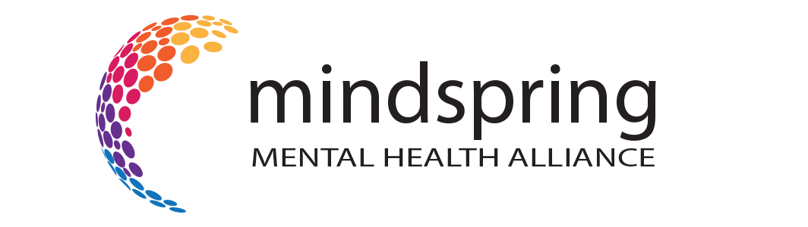

Low Cost / No Cost Psychotherapy Resources

Best Free Online Therapists in 2021 https://www.healthline.com/health/mental-health/online-therapist-for-free

Best Free Online Therapy Providers in 2022 https://www.onlinetherapy.com/free/

Covid Recovery Iowa https://www.covidrecoveryiowa.org/

Open Path Psychotherapy Collective https://openpathcollective.org/

Open Counseling https://www.opencounseling.com/

